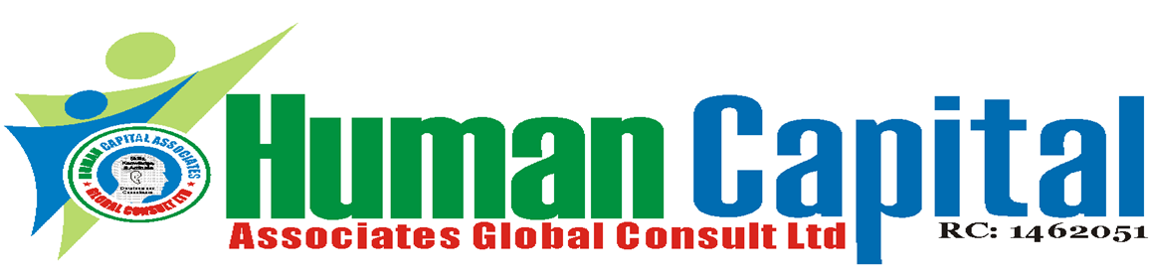
Workshop on Effective Healthcare Management System
January 17 – 21, 2022, 1st Run: Lagos & Abuja
July 18 – 22, 2022, 2nd Run: Lagos & Port Harcourt
For Tutor -Led Class: 9am – 4:30pm
U$D Equivalent for foreign Participants

Workshop fee: N180, 000 per Participant
For online: Delivery via Zoom
Time: 9am – 4:00pm everyday
Online course fee: N150, 000 per Participant
Available for In-plant Training
Program overview:
Effective public health service delivery continues to remain a challenge in Nigeria. Over the past decades medical services are delivered in an environment of poor infrastructures and scarce resources. Healthcare administrators in Nigeria must now take a step back from their day to day operational challenges and take a strategic look at the quality of care, management, finances, productivity and growth of this vital industry. This workshop aims to equip clinicians and other health administrators with the skills to design and implement strategies for effective healthcare delivery and organizational change.
For whom:
Medical Directors, Hospital Directors, Medical Doctors, Head of Administration, Senior Doctors and Senior Officers in private hospitals, Clinics, Specialist Hospitals, Government Hospitals, Research and Medical Centers, Chief Medical in Pediatrics, Cardiology, Neurology and Gynecology and third sector health organizations involved in managing healthcare delivery system.
Learning objectives:
At the end of the program, participants will be able to;
- Define their priorities and develop leadership skills for working with staff and stakeholders to develop and deliver more productive healthcare services
- Enhance your skills for guiding the work of clinicians through clinical governance and healthcare standards
- Work with the whole healthcare system to achieve sustainable change
- Appreciate HR's role as a vital contributor to a productive healthcare system
- Discover strategies to attract and retain top talent
- Examine best practices for managing performance and creating compensation, training and benefit systems that drive bottom-line results
- Appreciate the patients as the center piece of any successful healthcare system
LOCATIONS
1 - HCA Learning Centre. Acme House 2nd Floor, 23, Acme Road, Ogba, Industrial Scheme, Ikeja, Lagos, Nigeria

2 - Green-Minds Hotel, Plot 764, Cadastral Zone B05,
E. Ekukinam Street, Utako District, Abuja

3 – Pakiri Hotel, 4 Okwuruola Street, Off Stadium Road, Rumuola,
Port Harcourt
Open Course Fee: N180, 000
In-plant Fee Negotiable
WORKSHOP FEE:
N180, 000 per participant, VAT –N13, 500
Note: this covers Workshop Fee, Tea/coffee break, Lunch, course materials and certificate of attendance.
Payment should be made into our Accounts:
Account Name:
Human Capital Associates Global Consult Ltd.
Union Bank of Nig. PLC: Account No: 0097961537
First Bank of Nig. PLC: Account No: 2033683960
Keystone Bank Ltd.: Account No: 1007150325

For Booking / Enquiry, Call: 234-8145745664, 234-8184727337
24/7 Lines: 234-8068933608, 234-8029170491 & 234-8051365946

Course outline:
Day 1: Global Best Practice for Sustainable Healthcare System
- Understanding the Global Healthcare Trends and Challenges
- Investment in Healthcare - Meaningful Return, Disastrous Failure
  - identifying Hospital Risk Exposure and Risk Tolerance
  - Assessing Various Financing Methods and identifying
  - the best options
Day 2: Integrating Talent Management to Optimize Workforce Performance
- International Standard
- Factors Influencing Good Nursing Care
- Designing Attractive Compensation System and Incentive based
- Organizational Culture
Day 3: Journey to Excellence in Quality Service
- Implementing total quality management
to strengthen hospital management and practice
- Striking a balance between high quality care and a reasonable ROI
- Global best practices for a sustainable healthcare system
Day 4: Designing Healthcare Services Process for Quality, Effectiveness and
Cost Efficiency
- Building Hospital Reputation
- Understanding and Learning from Consumer demand
Day 5: Streamlining the Hospital Processes by Using IT to achieve Cost Efficiency
- Moving from Quality to Excellence using IT
- Effective Use of IT to Minimize Medical Error
- Human Resource Management in Today’s Healthcare
Training Methodology
Lectures, discussions, exercises, and case studies will be used to reinforce these teaching/learning methods.

