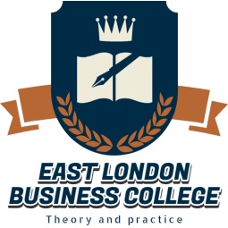
EAST LONDON BUSINESS COLLEGE, UNI TED KINGDOM,

IN CONJUNCTION WITH
RIVERFORD BUSINESS SCHOOL PH

PRESENTS:
BRITISH EXECUTIVE MASTERS CERTIFICATE IN
PROJECT MANAGEMENT

1. BACKGROUND
Project management skills affords you the opportunity to become more effective and efficient in your job particularly in the area of delivering to time, quality and budget. This programme will help candidates to acquire the necessary PM skills, knowledge, concepts and methods for easy completion of enterprise projects.
2. FOR WHOM
This program has been carefully designed for graduates who wish to boost their CV, who intent to take on Project Management positions, Project Officers, Project Managers, Line Mangers, Engineers, Medical doctors, Bankers, Insurers, Estate Managers, Accountants, Supervisors as well as Executive Level Management staff.
3. ADVANCED PROJECT MANAGEMENT MODULES.
1.Introduction to Project Management 2. Project Initiation & Planning 3.Global Project Management. 4.Project Quality & Risk Management 5. Project Time & Scope Management 6.Project Leadership 7.Project Cost & Stakeholder Management.
Duration: 2days
4. AWARDING BODY
The East London Business College UK www.elbc-edu.org.uk
DATES: Saturday ^{3rd} & Sunday 4th October 2018
Venue: 202 Peter Odili Road, JDP Roundabout, Trans-Amadi, PH.
Time: Saturday 10am-4pm & Sunday 1pm-4pm
Fee:N70,000 Covers Training Materials, Lunch Break and UK Certificate
PAYMENT: Account Name: Riverford Business school. Bank Name: Zenith Bank, Account number:1015302965.
Call to Register: +2348063335472

